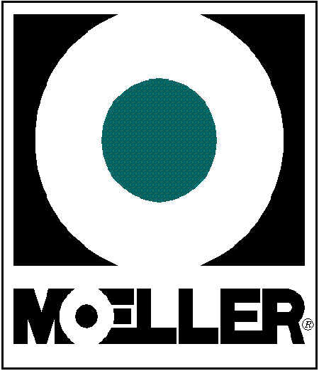

Quality Policy

“Moeller Marine will strive to exceed our customers’ expectations. We will meet the requirements of ISO 9001:2015, provide a framework for setting our quality objectives, and utilize the quality management system to drive continual improvement”

