

MOELLER MARINE PRODUCTS

A Moore Company

Product: Fuel Tanks

Topic: Retrofit

Subject: Sending Units

Retrofit Procedures

Supplies Needed: (5) Washer-Gaskets and (5) Hex-head machine screws. (Provided)

Tools Needed: Phillips hand screwdriver; Torque wrench which reads in/lb and a 5/16” socket attachment.

Retrofit Instructions:
- Use the “Star Pattern” as illustrated below to remove / replace one screw at a time.
Do not remove the sending unit.
- Replace each removed screw with a washer-gasket and hex-head machine screw combination. Make sure the gasket part of the washer-gasket is applied to the surface of the sending unit.
- Hand-tighten each replaced screw a few turns; this will prevent cross threading.
- Using the torque wrench tighten the screw to 25 in/lb.
- Continue until all 5 screws are replaced.

Note: If the seal between the sending unit and the fuel tank is broken, the tank should be pressure checked in accordance with ABYC H-24.17.4. Do not exceed 3 psi.

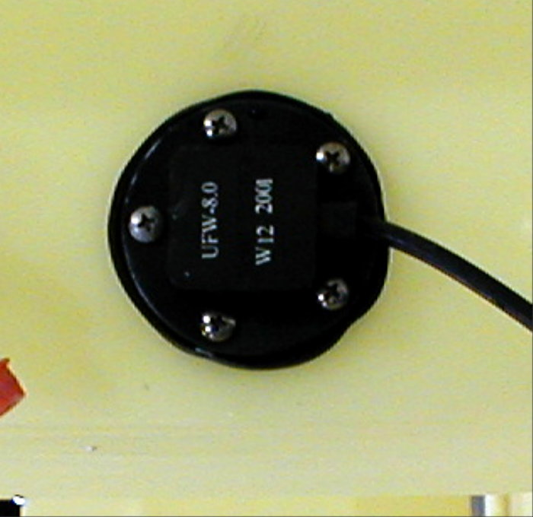
#1
#2
#3
#4
#5

09/10/2001

