

MOELLER MARINE PRODUCTS

A Moore Company

Product: Fuel Tanks

Topic: Retrofit

Subject: Anti-Siphon Valve

Retrofit Procedures

Supplies Needed: (1) ¼” x 3/8” anti-siphon valve -15” calibrated (provided).

Tools Needed: Crescent wrench or 9/16” deep well socket and ratchet.

Retrofit Instructions:
- First check the barb fitting to see if an anti-siphon valve is already in place via visual inspection (see photo 1 and photo 2). If you are still unable to determine whether an anti-siphon valve is already in place, insert a rod or dowel less than ¼” in diameter into the end of the fitting (see photo 3). If the rod or dowel penetrates the end of the fitting more than 1 ¾”, then an anti-siphon valve is not present and you should continue.
- Remove clamp and hose from fitting.
- Turning counterclockwise, remove the barb fitting.
- Remove protective cap over threads on the provided anti-siphon valve.
Note: Thread sealant has already been applied to the threads.
- Turning clockwise, hand-tighten the provided anti-siphon valve in order to prevent cross threading.
- Using the crescent wrench or 9/16” deep well socket and ratchet tighten anti-siphon valve.
Note: This is an NPT thread so tighten to a sealed condition.
- Re-install the hose and clamp.
- A pressure check should now be done in accordance with ABYC H-24.17.4.
Do not exceed 3 psi.
- In the event that the replaced fitting demonstrates a leak during the pressure test, tighten the anti-siphon valve until a proper seal is achieved. Retest.

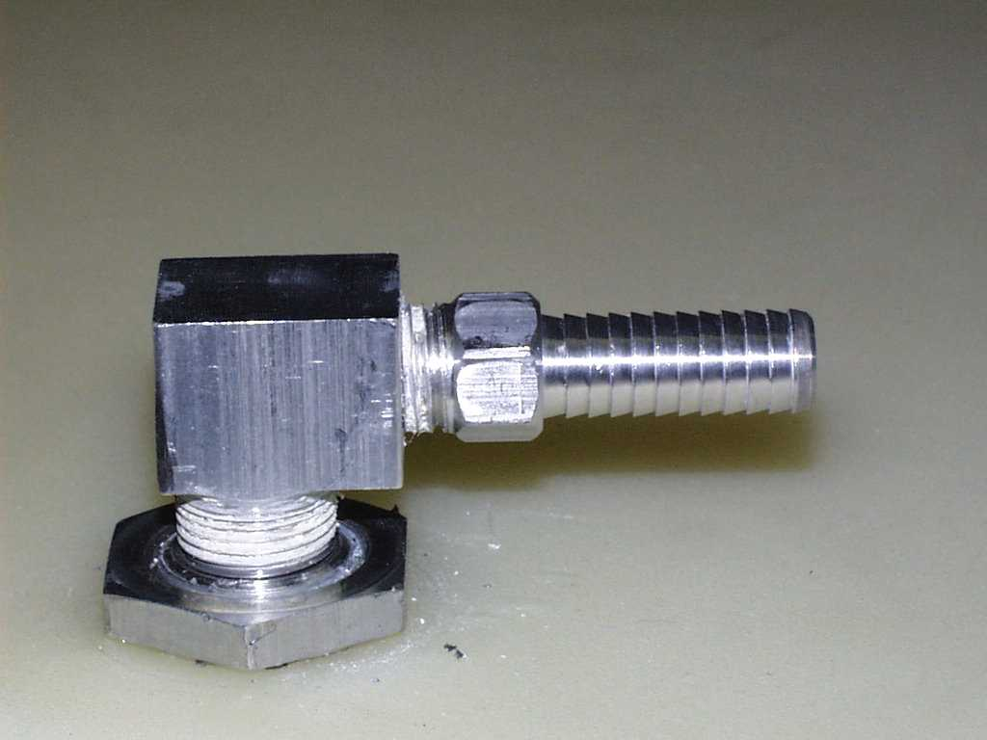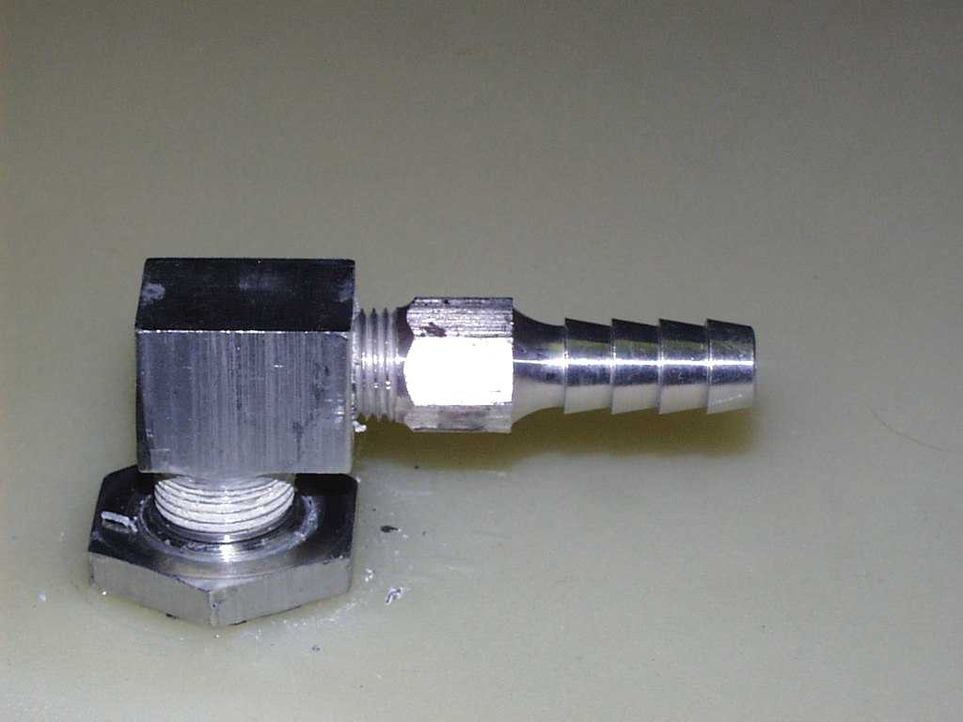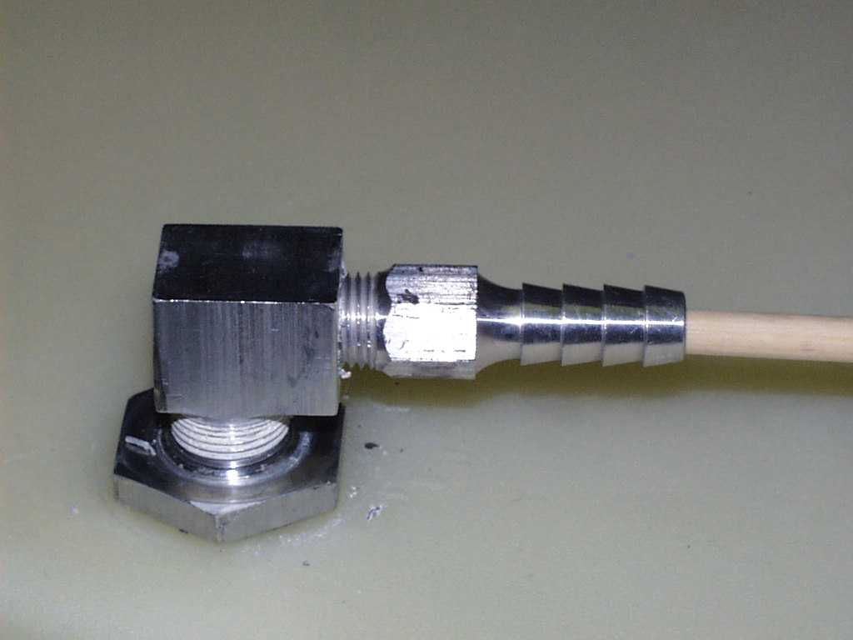
0.365” Flat
0.565” Flat

* Std Barb fitting (photo 1) *Anti-siphon valve fitting (photo 2) * Dowel test (photo 3)

10/14/2007

