

MOELLER MARINE PRODUCTS

A Moore Company

Product: Fuel Tanks

Topic: Repair

Subject: Pickup/Vent Insert PL3
Pop Lock

Repair Procedures

Supplies Needed: Parker “O’ Ring Lube; spray bottle with soapy water.

Tools Needed: 1 1/4” or 1 3/8” open end wrench; vise grips; needle nose pliers; torque wrench which reads in ft/lb and a 1 1/4” or 1 3/8” socket; pressure checking equipment.

Repair Instructions:
- Using the vise grips, attach and pull vertically to the PL3 Pop Lock Elbow, remove the pickup or vent fitting. Note: If needed loosen the jam nut to assist with removal.
- With either the 1 1/4” or 1 3/8” open-end wrench remove the jam nut from the molded in insert.
- Carefully remove any sealing material left on the tanks mounting surface. Make sure that the mounting surface is clean and clear of any obstructions, or debris.
Do not gouge or cut into the plastic material.
- Clean all applicable threads and openings (tank insert pickup or vent elbow). Inspect all threads and items for damage.
- Hand-tighten the jam nut until it meets the plastic surface.
- Using the torque wrench and either the 1 1/4” or 1 3/8” socket carefully tighten the jam nut to a torque of 70 ft/lb.
- Apply Parker “O” Ring lube to the o-rings on the replacement PL3 Pop Lock Elbow.
- Use the needle nose pliers to compress the snap ring. Press the PL3 Pop Lock Elbow down until the elbow is flush with insert (Listen for “POP” ensure the C ring is seating.)
- A pressure check should now be done in accordance with ABYC H-24.17.4.
Do not exceed 3 psi.
- In the event that the jam nut or elbow displays a leak during a tank pressure test, repeat procedure until a proper seal is achieved.

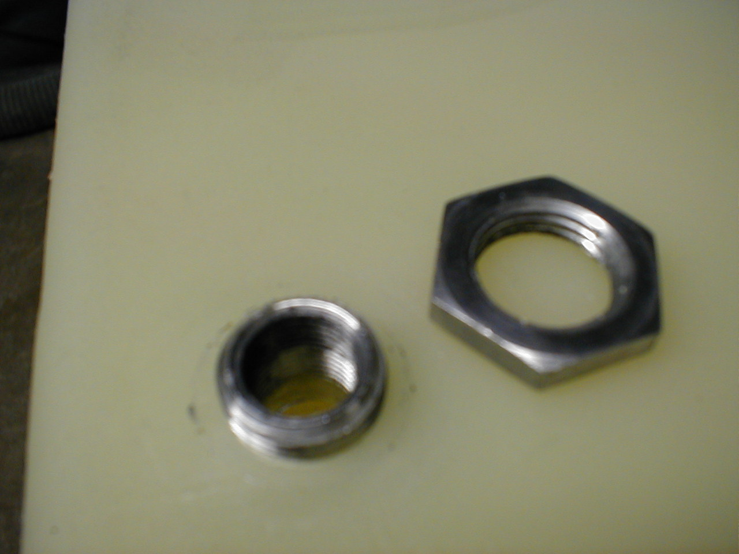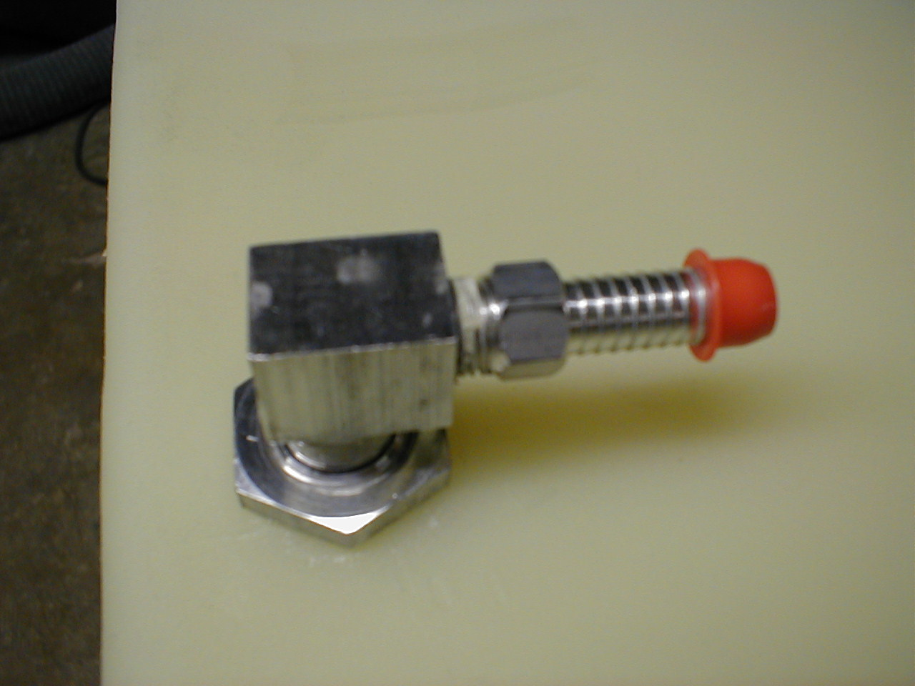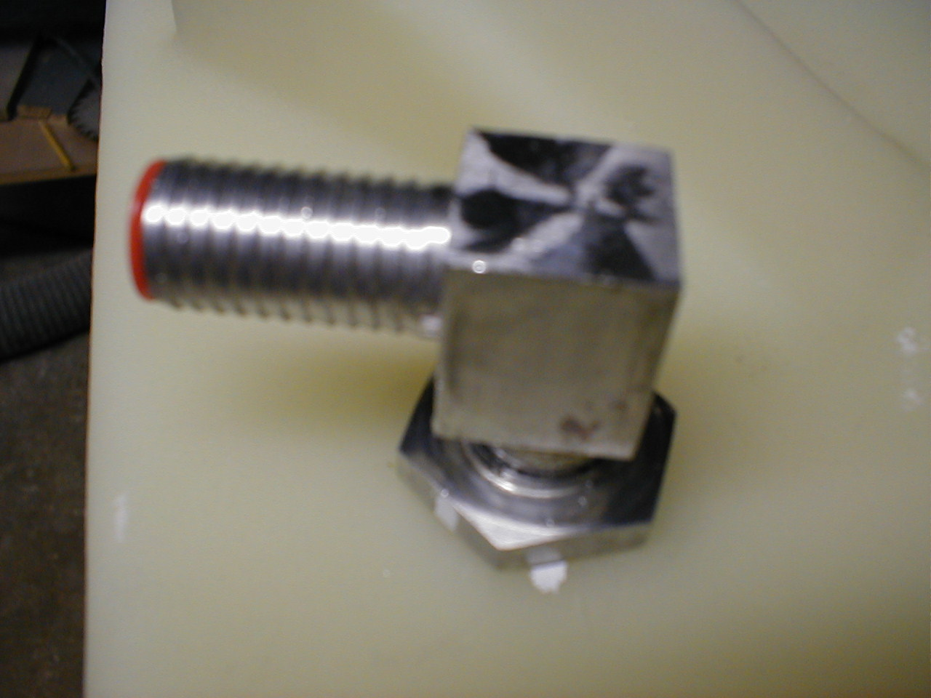
* Molded-in insert & Jam nut * Standard Pickup Assembly * Standard Vent Assembly

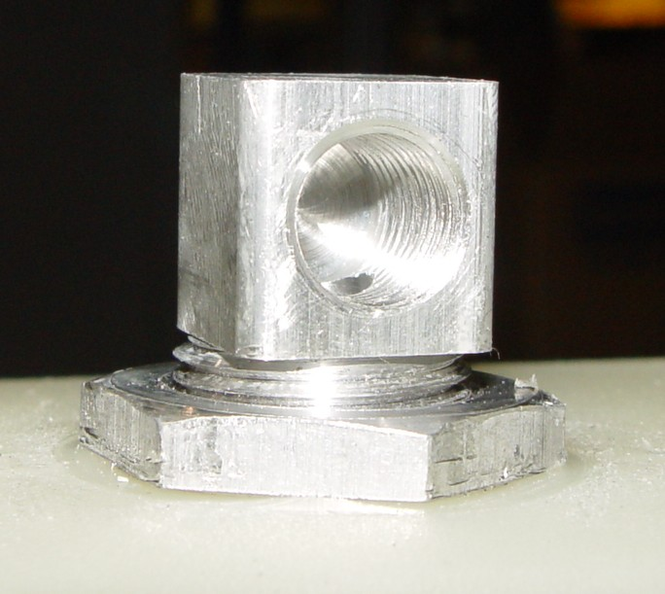
When assembling the Pop Lock fitting, be sure the fitting is completely seated as shown. Make sure the “Snap Ring” is not jammed in the insert.
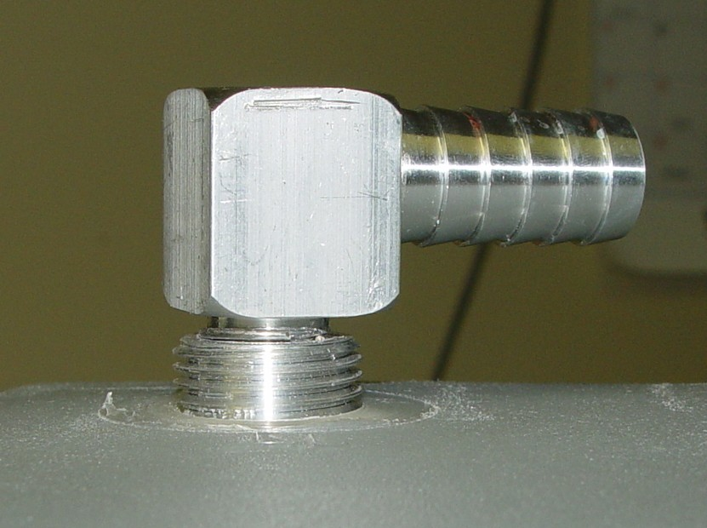
NO GO – the snap ring is jammed in between the bottom of the pickup head and the molded-in insert

