

MOELLER MARINE PRODUCTS

A Moore Company

Product: Fuel Tanks

Topic: Repair

Subject: Pickup/Vent Insert

Repair Procedures

Supplies Needed: Slic-Tite thread sealant; spray bottle with soapy water.

Tools Needed: 1 1/4” or 1 3/8” open end wrench; crescent wrench; torque wrench which reads in ft/lb and a 1 1/4” or 1 3/8” socket; pressure checking equipment.

Repair Instructions:
- Using the crescent wrench, turning counter-clockwise, remove the pickup or vent fitting.
- With either the 1 1/4” or 1 3/8” open-end wrench remove the jam nut from the molded in insert.
- Carefully remove any sealing material left on the tanks mounting surface. Make sure that the mounting surface is clean and clear of any obstructions, or debris.
Do not gouge or cut into the plastic material.
- Clean all applicable threads (tank insert, pickup or vent elbow). Inspect all threads for damage.
- Hand-tighten the jam nut until it meets the plastic surface.
- Using the torque wrench and either the 1 1/4” or 1 3/8” socket carefully tighten the jam nut to a torque of 70 ft/lb.
- Apply Slic-Tite thread sealant to the pickup or vent elbow threads.
- Re-install the pickup or vent elbow using the crescent wrench. Tighten the re-installed fitting.
Note: This is an NPT thread so tighten to a sealed condition.
- A pressure check should now be done in accordance with ABYC H-24.17.4.
Do not exceed 3 psi.
- In the event that the jam nut or elbow displays a leak during a tank pressure test, tighten the jam nut or elbow until a proper seal is achieved.
Note: Over-aggressive tightening may cause damage to the inserts.

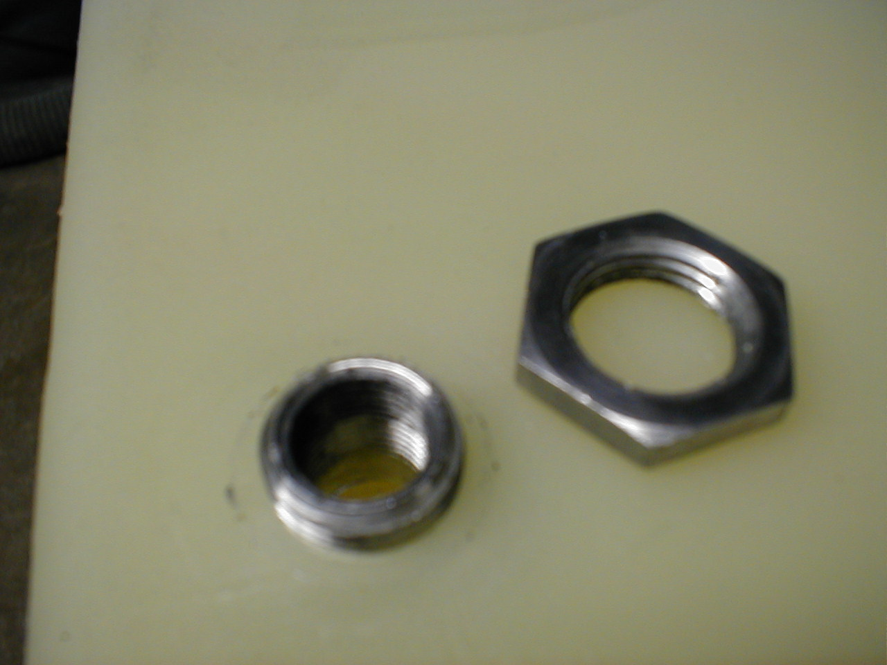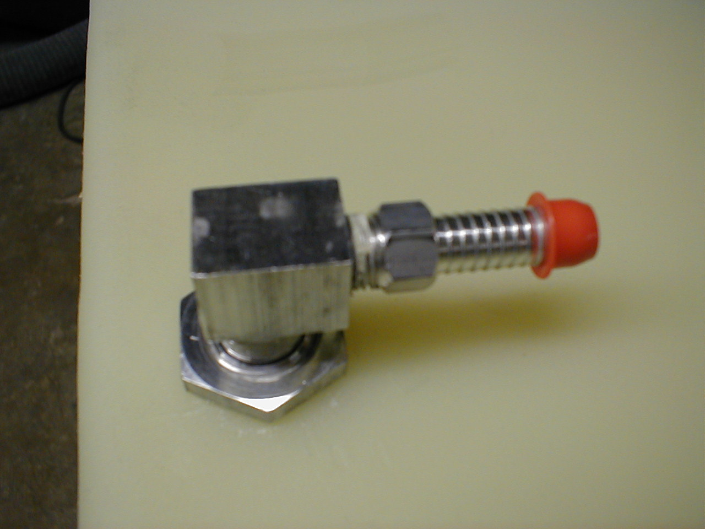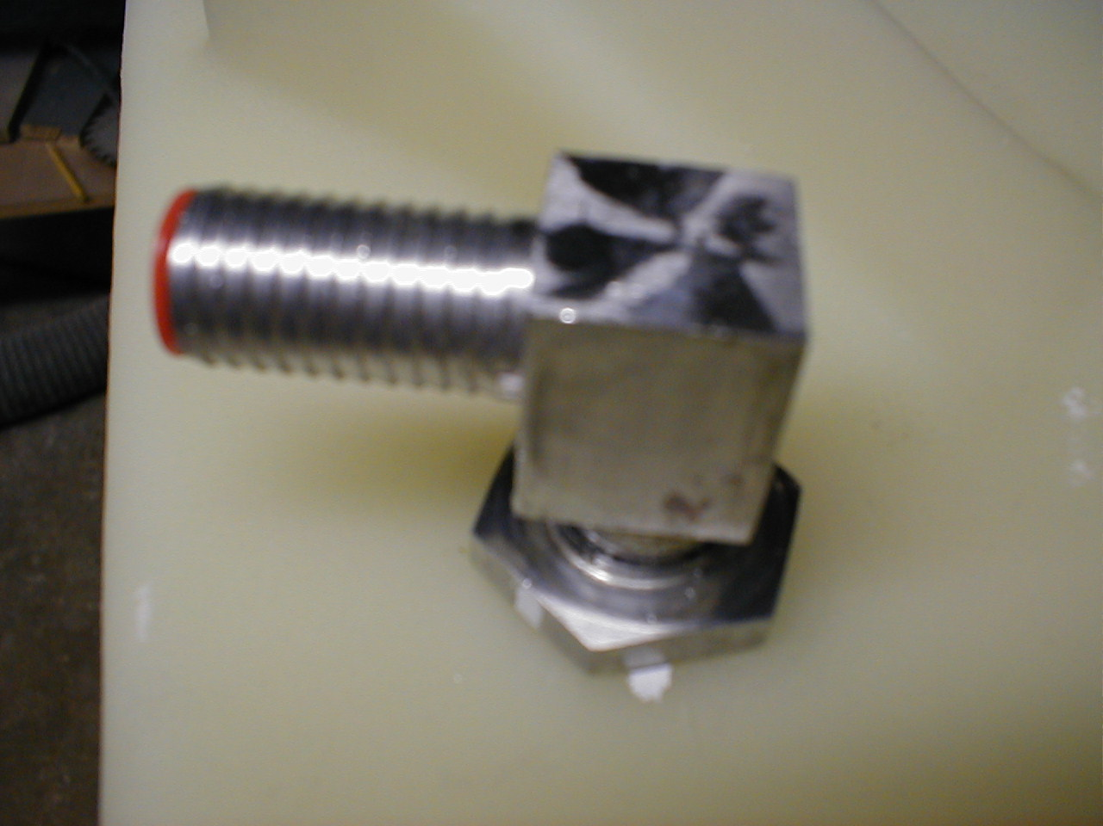
* Molded-in insert & Jam nut * Standard Pickup Assembly * Standard Vent Assembly

10/10/2007

